KANE COUNTY

DIVISION of TRANSPORTATION

Carl Schoedel, P.E.  Director of Transportation  County Engineer |  | 41W011 Burlington Road  St. Charles, IL 60175  Phone: (630) 584-1171  Fax: (630) 584-5239  www.co.kane.il.us/dot
January 27, 2022

OVERSIZE OVERWEIGHT PERMIT POLICIES

Applications for Oversize/Overweight (OS/OW) Moving Permits are made using the Oxcart Permit Systems website, www.oxcartpermits.com. One application can be submitted to cover use of both Kane County routes and one or more township routes in Kane County. When submitting applications, please refer to the following information about the two main types of OS/OW moving permits.

15-day Permit Fee Schedule (Oversize/Overweight)
 |  | Standard Vehicle |  |  | Non-Standard Vehicle
 | One-way | $50 |  |  | $100
 | Round trip | $85 |  |  | $135

15-day permits require a specific road-by-road routing to be used. This fee schedule applies to a single road jurisdiction (County or Township). If additional road jurisdictions are used, the same fee schedule would also apply to the additional road jurisdiction(s).

All KDOT bridges (see map) are structurally evaluated biennially (every two years) using KDOT’s standard vehicle configurations:
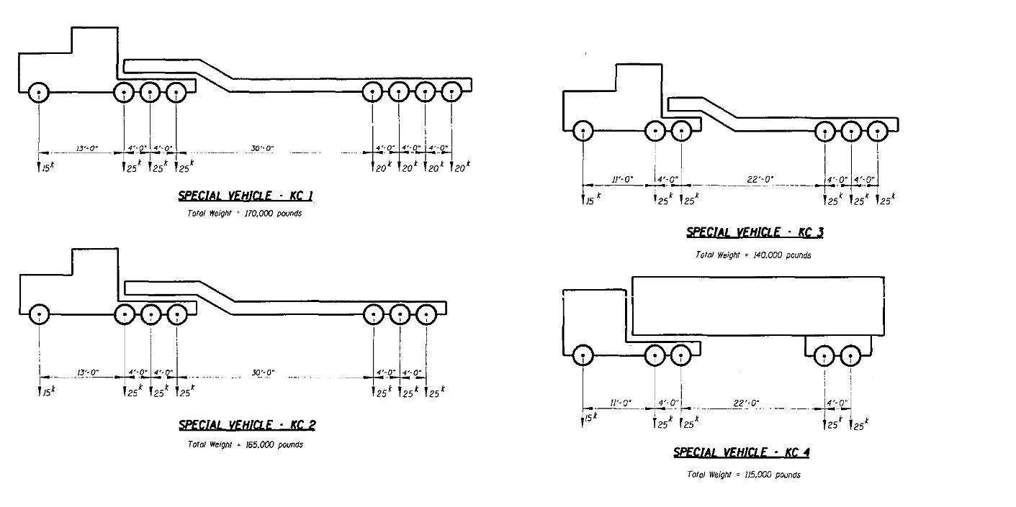
OS/OW applications of Standard Vehicles that cross bridges are reviewed by KDOT staff for approval.
Non-Standard Vehicles that cross a bridge will require an individual structural evaluation, which will require additional coordination with KDOT staff. Vehicles are considered to be Non-Standard if:

- Gross vehicle weight exceeds those listed above for 5-,6-,7-, and 8-axles.
- Steer axle weight exceeds 15,000 pounds.
- Any non-steer axle weight exceeds 25,000 pounds.
- The vehicle is a self-propelled crane.

90-day Permit Fee Schedule (Oversize only)

 | Vehicle (oversize only)
Limited Continuous Operation | $250

90-day permits allow for an unlimited number of moves for single, specific pieces of equipment or non-divisible product. A single 90-day permit is not valid for multiple moves of similar equipment or products – permits are associated with the specific equipment or product being moved. For example, a 90-day permit cannot be used to cover dozens of deliveries of a given truck over a 3-month period. A 90-day permit could be used to move an oversize trailer to various sites over a 3-month period.

90-day permits do not require a specific road-by-road routing, but only are valid for roads in a given road jurisdiction (County or Township). If roads in additional road jurisdictions are used, the same fee schedule would also apply to the additional road jurisdiction(s).

Example 90-day permit: County roads $250
First Township roads $250
Second Township roads $250
$750

